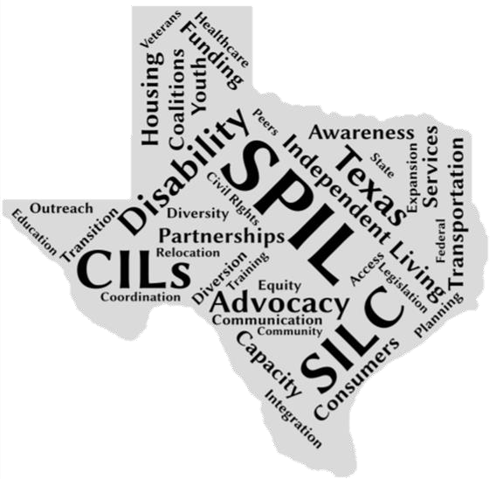

**Texas State Plan For**

**Independent Living FY 17-19**

1

# Executive Summary

This past year, Texans worked tirelessly to expand and improve access to Independent Living services in their communities. In this remarkably vast and diverse state, addressing the needs of the 3.4 million Texans living with a disability can be challenging. In order to give everyone an opportunity to share their voice, The Texas State Independent Living Council (SILC) endeavors to gather input from all communities, large and small, so their needs are addressed in statewide planning efforts.

In collaboration with Texas’

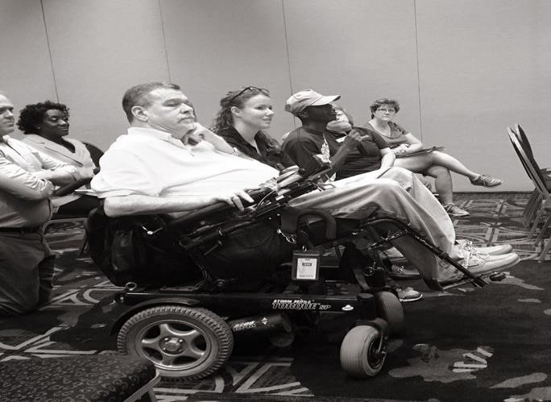

twenty-seven Centers for Independent Living, the Texas Health and Human Services Commission, and community stakeholders, the Texas

SILC drafts a three-year plan called the State Plan for Independent

Living (SPIL). The SPIL outlines specific goals and objectives for Independent Living Services, which are carefully devised using input gathered at public forums over a three-year period. The end of September marked the close of the first year of the FY17-19 SPIL cycle with many notable achievements.

2

# FY17 in Review

* Information about State Plan for Independent Living (SPIL) activities for Fiscal Year 2017 was compiled through reports from respective agencies and through a quarterly survey system with the Centers for Independent Living (CILs), a network of centers which provide an array of Independent Living Services to consumers with disabilities in different areas across Texas.

* All data in this report is based on reported activities from CILs and the Texas State Independent Living Council (SILC) between October 2016 and September 2017

* The goals outlined in the SPIL are broken down into objectives with specific targets to be reached each fiscal year. For FY17, 25 targets were set and only 1 was not met.

* 20 of the 27 CILs participated in the reporting process this past Fiscal Year. The list of CILs that provided data on their SPILrelated activities this past Fiscal Year can be found on pg. 8

4

# Advocacy

*Texans with disabilities receive the necessary supports and services to become more independent.*

The Texas IL Network increased the inclusion of

people with disabilities on

boards and commissions

through nearly **200**

advocacy efforts

**Systems Change** The inclusion of people with disabilities in planning bodies can influence the policies, knowledge, and processes that shape our communities. Boards, commissions, advisory committees, and other groups with jurisdiction over services that impact people with disabilities may lack proper guidance on creating an accessible world for everyone. The Independent Living (IL) Community has worked to identify and target these groups for outreach so that accessibility issues will be effectively addressed. They have worked to bring awareness of accessibility issues to public meetings and encouraged boards and commissions to include people with disabilities. Likewise, in order to ensure that other underrepresented groups are involved in these planning bodies, the Texas SILC has begun research to include a Federally recognized tribe in Texas on its Council and will continue these efforts in FY18.

**Personal Care Attendants** This past year, the Texas IL Network focused extensively on improving personal care attendant (PCA) issues. Advocates made an ardent push for policy change, most notably the issue of persistently low attendant wages. They also spread awareness of the option to enroll in Consumer Directed Services (CDS), a program that allows people who receive services from the Texas Health and Human Services Commission (HHSC) to hire and manage the people who provide their services. Additionally, a collaborative effort between CIL and SILC staff helped produce a consumer support toolkit for PCA issues, a statewide resource for consumers that will guide them through the process of finding and managing a PCA. The toolkit will be finalized and available for distribution to consumers in FY18.

**Emergency Preparedness** While emergency preparedness has

been a predominant concern for people with disabilities, the mass destruction and displacement caused by Hurricane Harvey in September placed even greater scrutiny on efforts to improve awareness, communication, and collaboration. Along with advocacy efforts for state and local emergency officials to include the needs of people with disabilities in emergency planning processes, the IL community has worked to increase awareness of emergency preparedness and foster opportunities for tools and techniques to communicate with individuals with disabilities before and during emergencies. Many also participated in largescale evacuation exercises held across the state.



**CILs improved awareness at the state level**

**and community level through over**

**150**

**advocacy efforts.**

**Transportation** Communities all across Texas share a common concern for accessible transportation needs, especially with new technology such as transportation network companies drastically changing how people get around. Advocates pushed for more accessible public and private transportation, worked with the Texas Legislature for policy change, and trained people to be advocates for accessible transportation. The Texas SILC held an Accessible Transportation Summit in March that initiated dialogue between transportation experts and the community and trained 156 people as accessible transportation advocates.

**Housing** The SPIL focuses on accessible housing issues

so that individuals have access to integrated, affordable, and accessible housing within the community of their choice. Along with efforts to advocate for accessible housing, the IL community also worked with businesses, housing providers, developers, associations, and local governments to bring access awareness to universal design and universal communication access awareness and visitablility. CILs have also established 37 new housing coalitions and partnerships to increase housing opportunities for individuals with disabilities.

## Network Capacity and Sustainability

*The Independent Living Network operates effectively, is adequately funded, and has the capacity to expand.*

### Independent Living Transition: The network of



CILs have worked to ensure they have adequate resources and capacity to provide Independent Living Services for Texans with disabilities. They have participated in community awareness activities, participated in CIL peer support calls, and secured 35 new private funding sources. The SILC has contributed by raising funds for seven CILs serving consumers in areas affected by Hurricane Harvey, as well as including an additional CIL in a grant aimed at supporting Health and Fitness programs.

### Coordinating Funding for the Network: The network of

Centers for Independent Living have advocated to increase funding for services they provide to local communities and for expansion of services to underserved or unserved areas. They’ve advocated to the Texas Legislature and state agencies over 27 times to secure CIL funding in state laws. They’ve also worked to increase mobile, remote or virtual services options and reached out to community partners to use office space or locations regularly. Finally, CILs have worked to get consumer feedback on the use of federal funds for IL services in Texas.

### Reporting Consistency/Information Shared to

**Policymakers**: The Independent Living Network has worked to ensure accuracy and consistency of outcomes-based information to policymakers, grantors, and decision-makers.

CILs have shared success stories and the outcomes of the State Plan for Independent

Living over **167** times this year

CILs have also engaged with the Texas Legislature over **33** times, reporting on the success of their organization and the impact of Independent Living services on their communities

# Community Integration

*The Independent Living Network operates effectively, is adequately funded, and has the capacity to expand.*

**Youth Transition:** Centers for Independent Living have



taken the lead on bringing awareness of transition services to youth with disabilities. They engaged in 114 activities that include working with school systems and education service centers on youth access and utilization of transition services provided by Centers for Independent Living and other providers. They’ve also engaged in considerable outreach efforts to youth in underserved counties, populations, or racial groups in Texas.

**Relocation**: Relocation was a key issue for the IL community this past year; funding for these services was not included in the House or Senate Budget and were instead carved into managed care organizations. As a result, CILs secured commitments to continue relocation services through community based providers. CILs and SILC staff engaged in a number of activities for CILs to increase contracts or subcontracts for relocation services. Additionally, hundreds of outreach activities were conducted to increase awareness of relocation services to individuals with disabilities residing in institutions or nursing homes. CILs also coordinated efforts with outside entities on relocation issues.

**Diversion**: CILS have been working to increase access to diversion services for individuals with disabilities who are at risk for entering institutions or nursing homes. CILs have worked on a considerable number of other outreach initiatives. These include working with typically underserved communities, such as individuals with age-related disabilities, mental illness, substance abuse disorders, and youth.



The CIL N

etwork

provided

around



45



education

o

pportunities

for parents or

consumers

on

Medicaid

Long Term Services and

or waiver services

# Implementation

The Texas SILC conducts a bi-annual Implementation Review as part of its duties to “monitor, review, and evaluate the implementation of the State plan” as outlined in the Rehabilitation Act and the Workforce and Innovation and Opportunity Act (WIOA). This review focuses on various aspects of what is needed to implement the objectives in the State Plan for Independent Living. Two surveys were administered this past fiscal year; the survey data is reviewed for possible revisions or improvements to the State Plan.

CILs were asked about their organizations availability of resources (money, materials, facilities, etc) to implement and their progress in identifying, recruiting, and motivating a relevant number and type of participant for the activities in Fiscal Year 2017 (FY17). Below are some of the findings from the past two surveys.

Resources: **GOOD** Participants: **FAIR**

## Advocacy

Overall, CILs reported feeling “fair” about resources available for implementing advocacy activities in FY17. By mid-year, some CILs felt resources were lacking for activities on Personal Care Attendants, Emergency Preparedness, and Housing. By the 4th Quarter, these categories had moderately improved, but still remained “fair” overall. For participant recruitment, the overall sentiment has also been consistently “fair,” with a notable improvement for transportationrelated activities by the end of the fiscal year.

Resources: **FAIR**

Participants: **FAIR**

### Network Capacity and Sustainability

Both the availability of resources and participant recruitment for implementing activities for IL Network funding, growth, and sustainability have been “fair.” Fortunately, very few CILs feel that participant recruitment has been poor, with most ranking Independent Living transition as “good” by the end of the fiscal year. For resources, most CILs felt it was either good or fair, with IL transition being mostly good.

Resources: **GOOD**

Participants: **GOOD**

### Community Integration

Overall, CILs felt that both resources and participant recruitment were above average for community integration. Participant recruitment improved from fair to good by the end of the fiscal year. A majority of CILs felt they had a strong availability of resources for relocation and diversion activities.

# Consumer Satisfaction Data

The following is the aggregate consumer satisfaction data from the Centers for Independent Living Network in FY17. Consumers were asked to respond to the following survey questions regarding their satisfaction with their local Center.

**I have been treated in a friendly, caring, and respectful manner by the Center’s staff.**

|  |  |
| --- | --- |
| Strongly agree | 476 |
| Agree | 57 |
| Neutral | 1 |
| Disagree | 12 |
| Strongly Disagree | 0 |

**I have been treated in a friendly, caring, and respectful manner by the Center’s staff.**

|  |  |
| --- | --- |
| Strongly agree | 476 |
| Agree | 57 |
| Neutral | 1 |
| Disagree | 12 |
| Strongly Disagree | 0 |

**The Center’s staff responds to me/ provides services in a timely manner.**

|  |  |
| --- | --- |
| Strongly agree | 448 |
| Agree | 74 |
| Neutral | 13 |
| Disagree | 4 |
| Strongly Disagree | 1 |

**The Center’s services are meeting and/or have met my needs?**

|  |  |
| --- | --- |
| Strongly agree | 435 |
| Agree | 63 |
| Neutral | 28 |
| Disagree | 13 |
| Strongly Disagree | 4 |

**I am satisfied with the services provided by the Center and staff.**

Strongly agree 254

Agree 54

Neutral 5

Disagree 3

Strongly Disagree 0

**The Center’s services and staff provide me with information to help me make informed choices.**

Strongly agree 440

Agree 50

Neutral 18

Disagree 6

Strongly Disagree 2

**The Center’s staff encouraged me to make decisions so that I may live more independently.**

Strongly agree 419

Agree 43

Neutral 28

Disagree 19

Strongly Disagree 2

**How would you rate the overall experience with the Center?**

Excellent 62

Good 22

Fair 3

Poor 2

# Centers for Independent Living

The following Centers provided data on their SPIL-related activities in Fiscal Year 2017:

1. ABLE Center for Independent Living
2. Austin Resource Center for Independent Living– Austin
3. Austin Resource Center for Independent Living – San Marcos
4. Austin Resource Center for Independent Living – Round Rock

(Williamson County Center for Independent Living Services)

1. Brazos Valley Center for Independent Living
2. Coastal Bend Center for Independent Living
3. Crockett Resource Center for Independent Living
4. Disability in Action
5. Heart of Central Texas Independent Living Center
6. Life, Inc – Disability Connections
7. Life, Inc – LIFE/RUN
8. Palestine Resource Center for Independent Living
9. Panhandle Center for Independent Living
10. Rehabilitation, Education and Advocacy for Citizens With Handicaps (Disabilities), Dallas
11. Rehabilitation, Education and Advocacy for Citizens With Handicaps

(Disabilities), Denton

1. Rehabilitation, Education and Advocacy for Citizens With Handicaps

(Disabilities), Fort Worth

1. Rehabilitation, Education and Advocacy for Citizens With Handicaps

(Disabilities), Plano

1. San Antonio Independent Living Services
2. Valley Association for Independent Living – Rio Grande Valley
3. Valley Association for Independent Living – South Texas