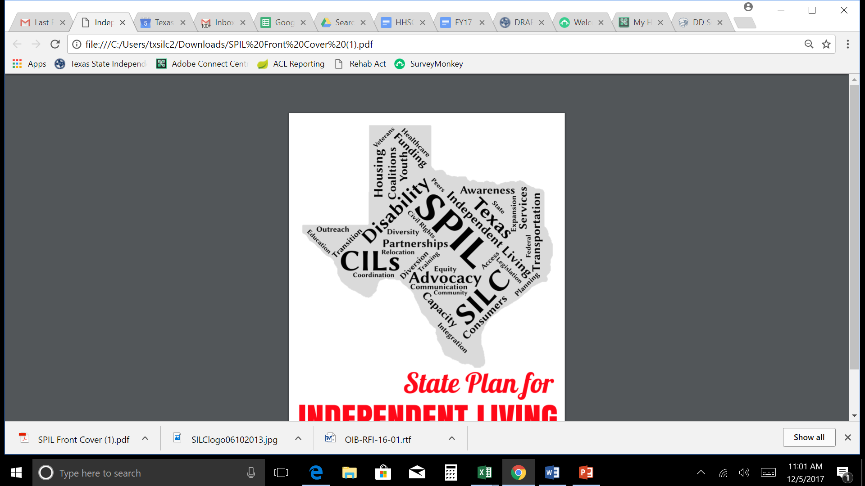

**FY18 Annual Report**

**Texas State Plan For**

**Independent Living FY 17-19**

# Introduction

This past year, Texans worked tirelessly to expand and improve access to Independent Living services in their communities. In this remarkably vast and diverse state, addressing the needs of the 3.4 million Texans living with a disability can be challenging. In order to give everyone an opportunity to share their voice, The Texas State Independent Living Council endeavors to gather input from all communities, large and small, so their needs are addressed in statewide planning efforts.

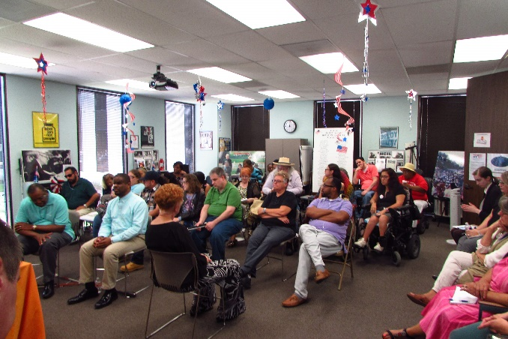In collaboration with Texas’ twenty-seven Centers for Independent Living, the Texas Health and Human Services Commission, and community stakeholders, the Texas SILC drafts a three-year plan called the State Plan for Independent Living (SPIL). The SPIL outlines specific goals and objectives for Independent Living Services, which are carefully devised using input gathered at public forums over a three-year period. The end of September marked the close of the second year of the FY17-19 SPIL cycle with many notable achievements.

# FY18 in Review

* Information about State Plan for Independent Living (SPIL) activities for Fiscal Year 2018 was compiled through reports from respective agencies and through a quarterly survey system with the Centers for Independent Living (CILs), a network of centers which provide an array of Independent Living Services to consumers with disabilities in different areas across Texas.
* All data in this report is based on reported activities from CILs and the Texas State Independent Living Council (SILC) between October 2017 and September 2018
* The goals outlined in the SPIL are broken down into objectives with specific targets to be reached each fiscal year. For FY18, 35 measurable targets were set and only 1 was not met.
* 19 of the 27 CILs participated in the reporting process this past Fiscal Year. The list of CILs that provided data on their SPIL-related activities this past Fiscal Year can be found on the last page

# Advocacy

*Texans with disabilities receive the necessary supports and services to become more independent.*

**Systems Change** The inclusion of people with disabilities in planning bodies can influence the policies, knowledge, and processes that shape our communities. The Independent Living (IL) Community has worked to identify, target and connect with these groups so that accessibility issues will be effectively addressed. A workgroup of CIL and SILC staff created and a Board Outreach Toolkit to increase awareness of disability types and their influence.

**Personal Care Attendants** Advocates are focused on strengthening the network of quality Personal Care Attendants for people with disabilities. This year, the IL Network participated in **126** advocacy activities to improve personal care attendant (PCA) issues. They finalized and disseminated a consumer support toolkit for PCA issues, a statewide resource for consumers that will guide them through the process of finding and managing a PCA. They also spread awareness of the option to enroll in Consumer Directed Services, a program that allows people who receive services from the Texas Health and Human Services Commission (HHSC) to hire and manage the people who provide their services.



The IL Network participated in **90** advocacy activities to increase awareness in the disability community

**Emergency Preparedness**. Along with advocacy efforts for state and local emergency officials to include the needs of people with disabilities in emergency planning processes, the IL community has worked to increase awareness of emergency preparedness and foster opportunities for tools and techniques to communicate with individuals with disabilities before and during emergencies.

**Transportation** The IL Network has pushed for policy change to improve accessible public and private transportation across Texas. An Accessible Transportation Summit was hosted in Waco in January, where experts trained around **115** people to be advocates for accessible transportation. The IL Network has also worked with the Texas Legislature and participated in over **112** advocacy activities.

**Housing** The SPIL focuses on accessible housing issues so that individuals have access to integrated, affordable, and accessible housing in the community of their choice. The IL community has worked with businesses, housing providers, developers, associations, and local governments to bring awareness of universal design and universal communication access and visitablility. CILs have also established **37** new housing coalitions and partnerships to increase housing opportunities for individuals with disabilities.

**96**

advocacy activities for accessible housing

# Network Capacity and Sustainability

*The Independent Living Network operates effectively, is adequately funded, and has the capacity to expand.*

**Independent Living Transition:** The network of CILs have worked to ensure they have adequate resources and capacity to provide Independent Living Services for Texans with disabilities. They have participated in community awareness activities, participated in CIL peer support calls, and secured **35** new private funding sources.

The IL Network advocated to the Texas Legislature and state agencies ****over **29** times to secure CIL funding in state laws.

**Coordinating Funding for the Network:**CILs have advocated to increase funding for services they provide to local communities and for expansion of services to underserved or unserved areas. They’ve also worked to increase mobile, remote or virtual services options and reached out to community partners to use office space or locations.

**Reporting Consistency/Information Shared to Policymakers**: The IL Network has worked to ensure accuracy and consistency of outcomes-based information to policymakers, grantors, and decision-makers. CILs have shared success stories and the outcomes of the State Plan for Independent Living over **221** times this year. CILs have also engaged with the Texas Legislature over **45** times, reporting on the success of their organization and the impact of Independent Living services on their communities

# Community Integration

*The Independent Living Network operates effectively, is adequately funded, and has the capacity to expand.*

**Youth Transition:** CILs have taken the lead on bringing awareness of transition services to youth with disabilities. They engaged in **126** activities that include working with school systems and education service centers on youth access and utilization of transition services provided by CILs and other providers. They’ve also engaged in considerable outreach efforts to youth in underserved counties, populations, or racial groups in Texas.



**Relocation**: CILs and SILC staff engaged in a number of outreach activities to increase awareness of relocation services to individuals with disabilities residing in institutions or nursing homes, including **319** outreach activities and **54** advocacy activities. CILs also coordinated efforts with outside entities on relocation issues.

**Diversion**: CILS have been working to increase access to diversion services for individuals with disabilities who are at risk for entering institutions or nursing homes, including **299** outreach activities. These include working with typically underserved communities, such as individuals with age-related disabilities, mental illness, substance abuse disorders, and youth.

# Centers for Independent Living

The following Centers provided data on their SPIL-related activities in Fiscal Year 2018:

Austin Resource Center for Independent Living– Austin

Austin Resource Center for Independent Living – San Marcos

Austin Resource Center for Independent Living – Round Rock (Williamson County Center for Independent Living Services)

Brazos Valley Center for Independent Living

Coastal Bend Center for Independent Living

Crockett Resource Center for Independent Living

Disability in Action

Heart of Central Texas Independent Living Center

Life, Inc – Disability Connections

Life, Inc – LIFE/RUN

Palestine Resource Center for Independent Living

Panhandle Center for Independent Living

Rehabilitation, Education and Advocacy for Citizens With Handicaps (Disabilities), Dallas

Rehabilitation, Education and Advocacy for Citizens With Handicaps (Disabilities), Denton

Rehabilitation, Education and Advocacy for Citizens With Handicaps (Disabilities), Fort Worth

Rehabilitation, Education and Advocacy for Citizens With Handicaps (Disabilities), Plano

San Antonio Independent Living Services

Valley Association for Independent Living – Rio Grande Valley

Valley Association for Independent Living – South Texas